Heron’s Theorem
We want to find the shortest path from point A to the line and back to point B.
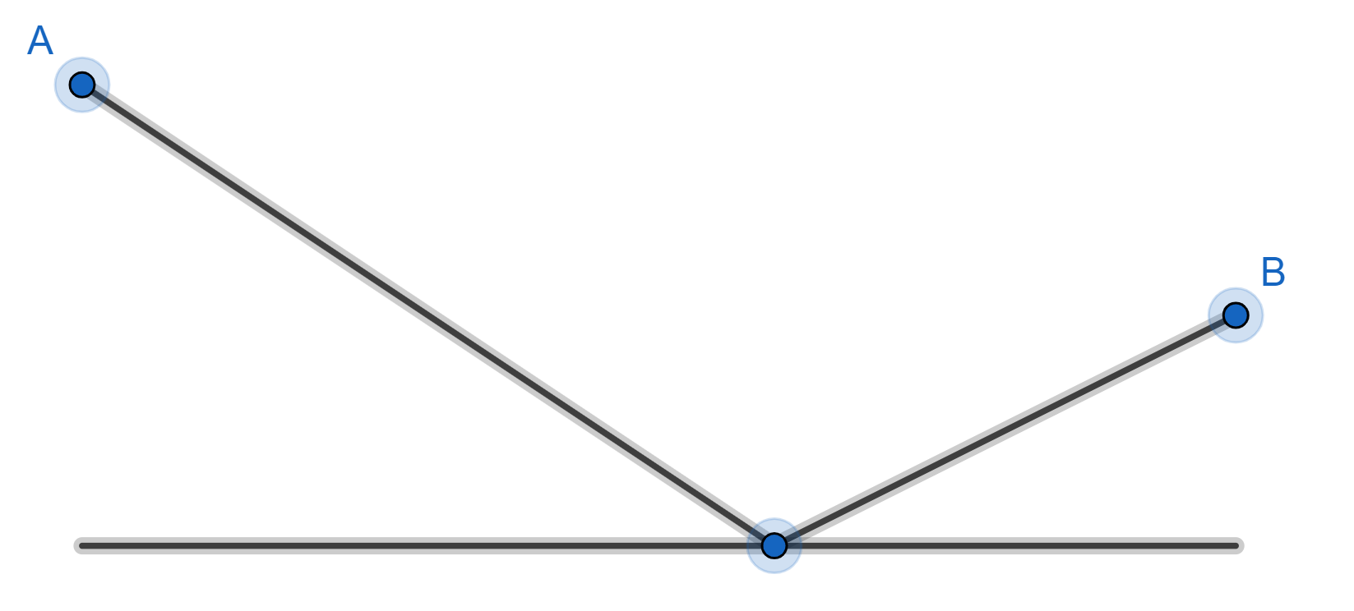

Reflect point B in the line to get point C
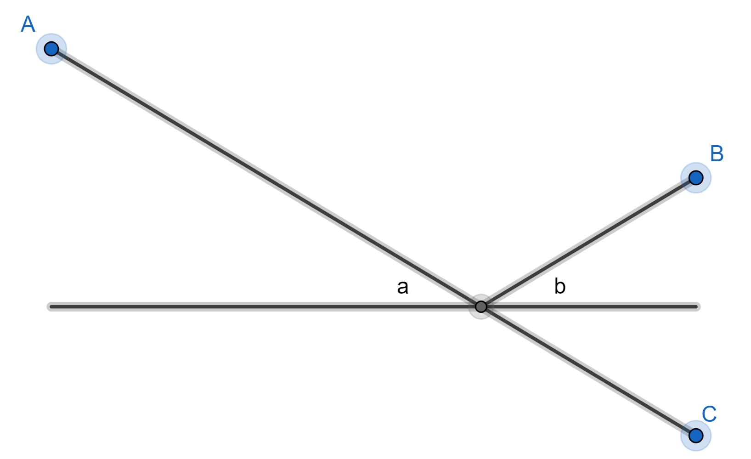

The distance from point A to the line and back to point B, is the same as the distance from point A to the line and on to point C. The shortest path from point A to the line and on to point C is a straight line. So the shortest path from point A to the line and back to point B is where angleis equal to angleThis is Heron’s theorem.
Incidently, if light travelled from point A to the line (which acts as a mirror) and back to point B then it would take this path (remember, angle of incidence equals angle of reflection)

